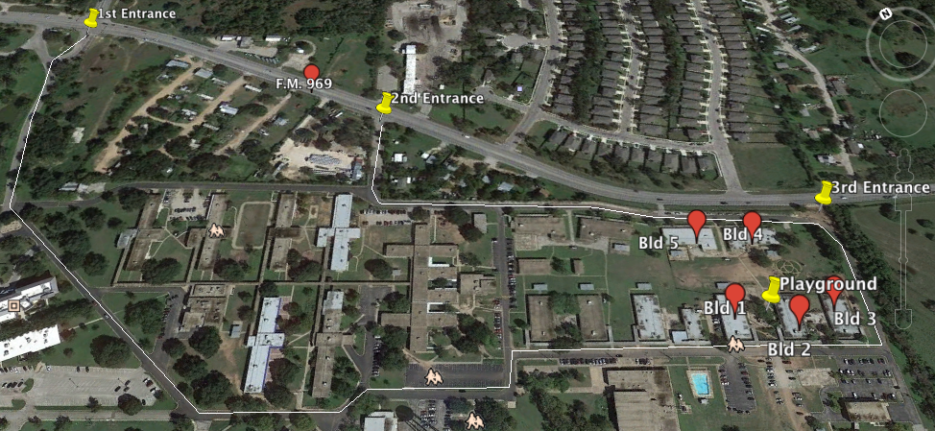

Austin Discovery School Traffic Flow
- Enter at 2nd or 3rd entrances. The 3rd entrance is right turn only. Exercise caution at the third entrance.
- Traffic flow is one-way, clockwise and exits at the 1st entrance.
- Student drop-off for all students is at the playground, between Buildings 1 and 2. K-5 students will be entering the playground, 6/7 grade students will cross back across the street with the help of the crossing guard outside building 1.
- Drop off and pick up in the right lane; passing is in the left lane. When picking up, please pull up as far as possible and wait for your student to be brought to your car.
- Prepare for a slightly longer pick-up time on Wednesday afternoons, as this is an early dismissal day for KIPP.
- Both the KIPP and the ADS campuses have increased enrollment this year and will be working together closely in the first few weeks of school to smooth out traffic flow as much as possible.

