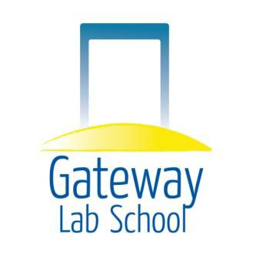
Gateway LabSchool

Alternative Performance Framework Task Force Meeting

DATE: May 12, 2015, 5:30 pm

LOCATION: 2501 Centerville Road, Wilmington DE (Room 103)

Task Force Team Members:
- Nate Schwartz – GLS Board – Parent Director
- Amy Sanders – GLS Educational Diagnostician
- Shaheda Pine – GLS Counselor
- Elizabeth Scheinberg – GLS Parent
- Bill Doolittle – DE State PTA and GACEC Leader
- Jodi Walder (Parent)
- Denise Stouffer – GLS Data Coach

The following agenda will be followed:

- Introduction of Denise to team
- Review of Previous Action Items
- Gateway Data Assessment to date – Denise
- Delaware Student Success Framework Meeting – Nate
- Discussion on what Alternative Performance Framework Task Force should focus on – ALL
- Path Forward
- Adjourn

Note: This is a public meeting and non-Task Force members are invited to attend.

