End-of-Year Grade submission
With the Seniors' grades needing to be completed sooner than the under-classmen, it has come to our attention that there needs to be some instruction as to how to handle inputting the grades. Since this came up late, your teachers have already chosen one of two ways to handle this.

The first option: A teacher can manually post the seniors' grades in Aeries.net using the "Edit All Records" button. From this screen, they can post just the senior grades. Then when it is time to post the under-classmen's grades, they can choose the other option of "Load Grades From Gradebook". They would then make sure the "Overwrite Existing Marks?" box is not checked.

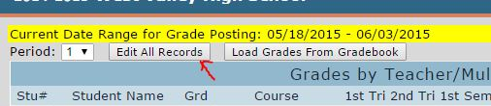

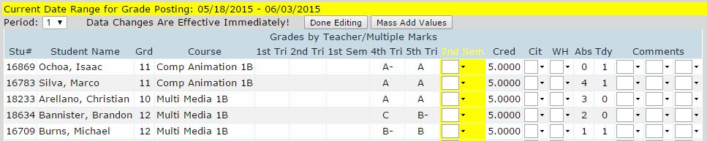

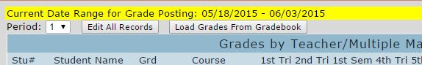

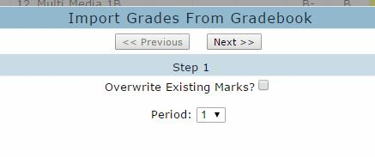
Leave this un-checked
The second option: A teacher can choose the "Load Grades From Gradebook", and post all the student's grades, not just the seniors. (Unfortunately, there is no option to choose only some students). Using this option, the teacher would then need to make sure that any additional assignments they have added to the gradebook after the seniors have completed their requirements have a mark of NA for the seniors. (i.e. An assignment that the underclassmen had to complete but the seniors were exempt from completing). Then, when it is time to update the underclassmen's final grades, the teacher would choose the "Load Grades From Gradebook", and make sure the "Overwrite Existing Marks?" box is checked. PLEASE make sure your seniors have the NA in any late-added assignments before proceeding to this last step.

Make sure this is checked

