Adding school email to an Android Phone
First- Go to your email settings and delete your present school email account.
Second- Add a new Account. Click Corporate (or your phone could have the choice Exchange)
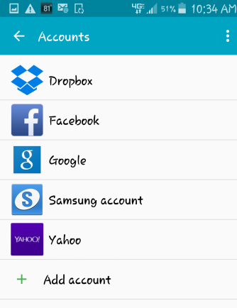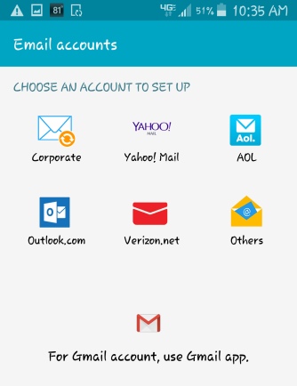
Third- Enter your email address and password. Click Next
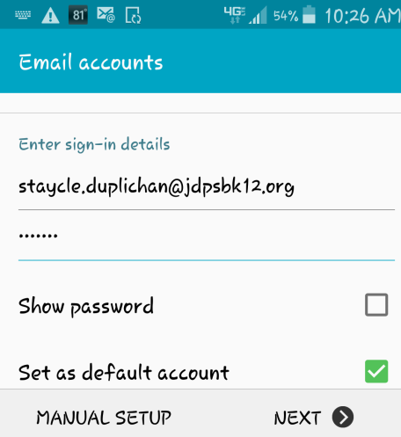
When you click NEXT, your phone will try to authenticate. Since it can’t, the following screen will appear. Your name will automatically appear in the Domain. Type detel in front of your name in the Domain. In the Exchange server type mail.jdpsbk12.org. Click Next.
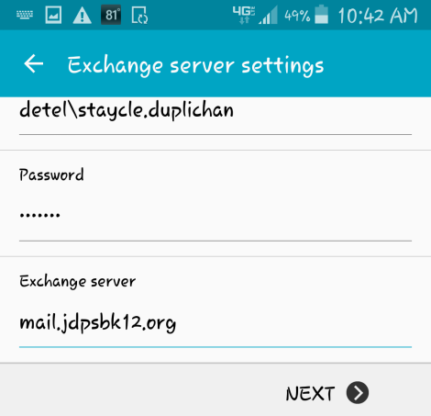
The next screen does not affect your email activation. It contains preference setting choices.

